Experiment - 5
Student Name: Mankaran Singh Tandon UID: 23BCS10204
Branch: BE-CSE Section/Group: KRG_2B
Semester: 5th Date of Performance: 22/9/25
Subject Name: Advanced Database and Management System
Subject Code: 23CSP-333

Problem Description/Aim:
Medium-Problem Title: Generate 1 million records per ID in ‘transaction_data’
using generate_series() and random() ,create a normal view and a materialized view ‘sales_summary’ with aggregated metrics (total_quantity_sold , total_sales, total_orders) , and compare their performance and execution time.
Procedure (Step-by-Step):
  - Create a large dataset:
    - Create a table names transaction_data (id , value) with 1 million records.
    - take id 1 and 2, and for each id, generate 1 million records in value column
    - Use Generate_series () and random() to populate the data.
  - Create a normal view and materialized view to for sales_summary, which includes total_quantity_sold, total_sales, and total_orders with aggregation.
  - Compare the performance and execution time of both.
Sample Output Description:
The transaction_data table has 2 million rows (1 million per ID) with random values. The normal view sales_summary computes aggregates on the fly, while the materialized view sales_summary_mv stores precomputed results. Queries on the materialized view are much faster, but it needs refreshing when data changes, whereas the normal view always shows up-to-date results.

Hard-Problem Title: Create restricted views in the sales database to provide summarized, non-sensitive data to the reporting team, and control access using DCL commands( GRANT and REVOKE).
Procedure (Step-by-Step):
- Create restricted views-
  - Define views that show only aggregated sales data (e.g., total_sales, total_orders) without exposing sensitive columns like customer details or payment info.

- Assign access to reporting team(or client)-
-Use “GRANT SELECT ON view_name TO reporting_user; “ to give access.
- Revoke access if needed.
-Use “REVOKE SELECT ON view_name FROM reporting_user;” to remove access.
- Verify access
  - Reporting users can query the view but cannot access base tables directly, ensuring security.
Sample Output Description:
The result shows the restricted view providing summarized sales data only like
- Columns shown are - product_id,total_quantity_sold, total_sales, total_orders
- Columns hidden are - Customer names, addresses, payment details

A reporting user querying the view sees something like :
- Product 101 - 5000 units sold, total sales Rs. 12,50,000,500 orders.
- Product 102 - 3200 units sold, total sales Rs. 8,60,000,320 orders.
When the user tries to query the base “sales_transactions” table directly, access is denied, enforcing security.

- Objective: To design and implement secure, efficient data access mechanisms by creating large-scale transaction datasets, summarizing them through normal and materialized views for performance comparison, and enforcing restricted access to sensitive data using views and DCL commands.

SQL QUERY AND OUTPUTS -
--------------------------------MEDIUM LEVEL PROBLEM---------------------------------------
Create table TRANSACTION_DATA(id int,val decimal); INSERT INTO TRANSACTION_DATA(ID,VAL) SELECT 1,RANDOM()
FROM GENERATE_SERIES(1,1000000);

INSERT INTO TRANSACTION_DATA(ID,VAL) SELECT 2,RANDOM()
FROM GENERATE_SERIES(1,1000000); SELECT * FROM TRANSACTION_DATA;

CREATE or REPLACE VIEW SALES_SUMMARY AS SELECT
ID,
COUNT(*) AS total_quantity_sold, sum(val) AS total_sales, count(distinct id) AS total_orders FROM TRANSACTION_DATA GROUP BY ID;

EXPLAIN ANALYZE
SELECT * FROM SALES_SUMMARY;

CREATE MATERIALIZED VIEW SALES_SUMM AS SELECT
ID,
COUNT(*) AS total_quantity_sold, sum(val) AS total_sales, count(distinct id) AS total_orders FROM TRANSACTION_DATA GROUP BY ID;

EXPLAIN ANALYZE
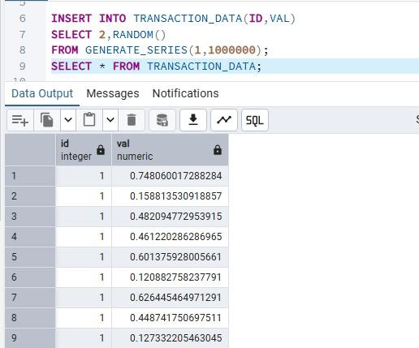
SELECT * FROM SALES_SUMM;

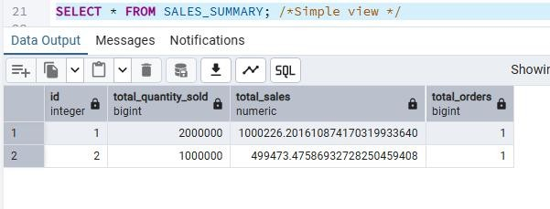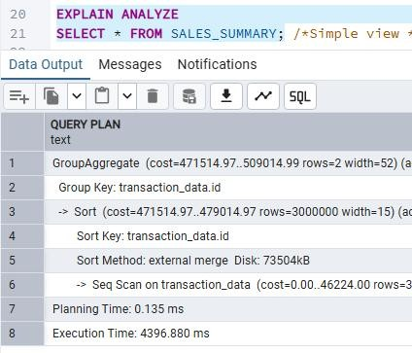
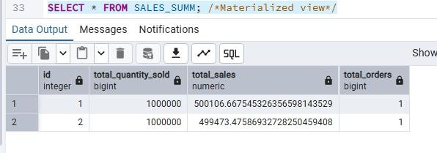

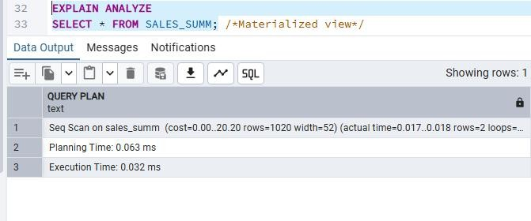
OUTPUT -
As we can see that the execution time using the materialized view is very less as compared to the simple view’s execution time.

------------------------------------------HARD PROBLEM --------------------------------------------

CREATE TABLE customer_data ( transaction_id SERIAL PRIMARY KEY, customer_name VARCHAR(100),
email VARCHAR(100), phone VARCHAR(15),
payment_info VARCHAR(50), -- sensitive order_value DECIMAL,
order_date DATE DEFAULT CURRENT_DATE
);

-- Insert sample data
INSERT INTO customer_data (customer_name, email, phone, payment_info, order_value) VALUES
('Mandeep Kaur', 'mandeep@example.com', '9040122324', '1234-5678-9012-3456', 500),
('Mandeep Kaur', 'mandeep@example.com', '9040122324', '1234-5678-9012-3456', 1000),
('Jaskaran Singh', 'jaskaran@example.com', '9876543210', '9876-5432-1098-7654', 700),
('Jaskaran Singh', 'jaskaran@example.com', '9876543210', '9876-5432-1098-7654', 300);

CREATE OR REPLACE VIEW RESTRICTED_SALES_DATA AS SELECT
CUSTOMER_NAME,
COUNT(*) AS total_orders, SUM(order_value) as total_sales from customer_data
group by customer_name;

select * from restricted_sales_data;

CREATE USER CLIENT1 WITH PASSWORD 'REPORT1234'; GRANT SELECT ON RESTRICTED_SALES_DATA TO CLIENT1;
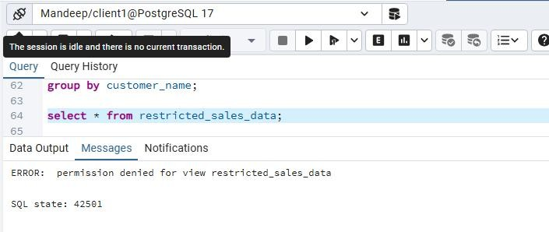
REVOKE SELECT ON RESTRICTED_SALES_DATA FROM CLIENT1;

